**Module 4 Challenge Written Report**

1. **Summarize the analysis:**

For convenience purposes, all numbers are rounded to 2 decimal places for the following analysis.

For the district summary analysis (see Table 1), it provides the following information:

Total Schools: 15

Total Students: 39170

Total Budget: $24,649,428.00

Average Math Score: 78.99

Average Reading Score: 81.88

% Passing Math: 74.98%

% Passing Reading: 85.81%

% Overall Passing: 65.17%



Table 1: District Summary

For the school summary analysis (see Table 2), information is calculated and organized by school. The table, by school, includes school type, total students, total school budget, per student budget, average math score, average reading score, % passing math, % passing reading, and % overall passing.

Table 2: School Summary

Based on “% Overall Passing”, Table 3 displays the top 5 highest-performing schools and Table 4 shows the bottom 5 performing schools. It indicates that Cabrera High School has the overall highest passing percentage score of 91.33% and Johnson High School has the overall lowest passing percentage score of 53.54%.

Table 3: Highest Performing School (by % Overall Passing)

Table 4: Bottom Performing School (by % Overall Passing)

Analyzing further by breaking down the math and reading scores by grade, Table 5 expresses the math average grade while Table 6 expresses the reading average grade between 9th to 12th for every school.

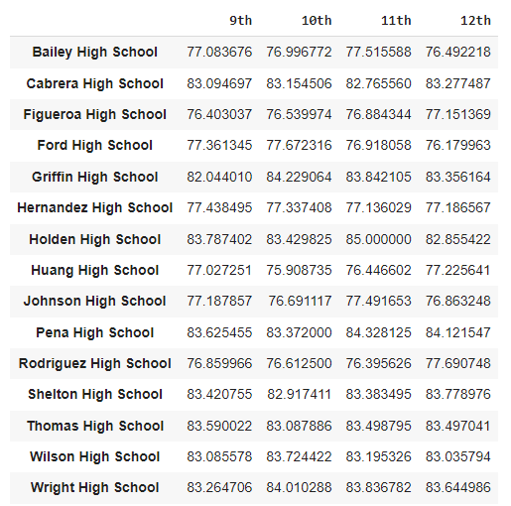

Table 5: Math Scores by Grade by School

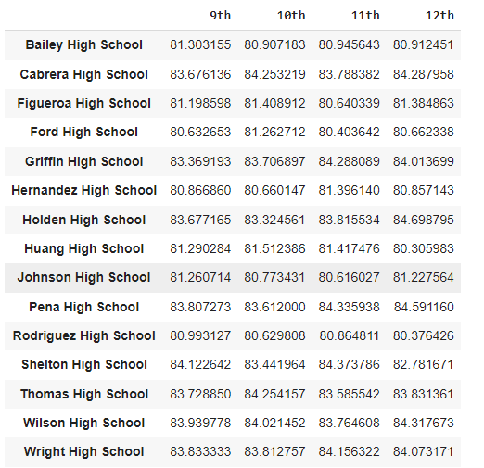

Table 6: Reading Scores by Grade by School

To evaluate scores by school spending, four bins, with reasonable cutoff values, were applied to construct Table 7. The spending bins are: 0, 585, 630, 645, and 680. Based on “Per Student Budget”, we determine the “Spending Range (Per Student)” that each school falls under, which is displayed in the last column.

Table 7: School Spending Scores by School

Calculating the averages for the desired columns, the result (Table 8) conveys the averages per various spending ranges. There is a significant trend in the analysis which will be discussed in detail in the following section.

Table 8: Scores by Spending Ranges Per Student

To evaluate the school size based on the total students per school, 3 categories (small having population of under 1000 students, medium having population between 1000 to 2000 students and large having population between 2000 and 5000 students). School size is displayed in the last column in Table 9.

Table 9: School Size Scores by School

In the following table, various average scores are analyzed against school size. Preliminarily, it can be determined that school size of small and medium conducts significantly better overall passing percentages than that of the school size of large. A more detailed discussion will be performed in the following section.

Table 10: Scores by School Size

Concluding the analysis by studying the scores based on the two different school types. It is apparent that charter type schools are generally performing better than that of the district type schools.

Table 11: Scores by School Type

1. **Draw two correct conclusions or comparisons from the calculations:**
2. From the Highest-Performing Schools (by % Overall Passing) and Bottom Performing Schools (By % Overall Passing) DataFrame, all top 5 schools have type “Charter”, and all bottom 5 schools have type “District”. Also, from Table 11, it shows that “Charter” has an overall passing percentage of 90.43% while district has a score of 53.67%. With this observation / conclusion drawn, the analyst could study the root cause (though both are public schools but operate under different governance) that is causing one type performing in generally better than the other. For example, Table 11 indicates that the difference between the “% Passing Math” is approximately 27.07%. The analyst can conduct root cause analysis to determine what leads to this significant gap.

Chart 1: Scores by School Type

1. Based on the “Spending Ranges (Per Student)” DataFrame, it indicates that <$585 has be highest average math & reading scores as well as highest math/reading/overall passing rate with these indicators dropping in numbers as the spending ranges increase. In Chart 2 (see below), it is graphically shown that the values drop in scores by school spending as the bins move up by brackets.

Chart 2: Spending Ranges (Per Student)

1. From the school size perspective, school size of small and medium is performing better than that of the school size of large. From Table 3&4, 3 medium sized schools, 1 large sized school and 1 small sized school consist of the 5 highest performing school while the bottom 5s are all large sized schools. The analyst can proceed to study the root cause that results in underperformance in large sized schools relative to other school sizes.

Chart 3: Score by School Size

Furthermore, based on all the factors evaluated, the analyst could conduct a “Design of Experiment” to study the relationship between multiple input variables and key output variables. For instance, for the highest 5 performing schools, all 5 schools have the type of “charter” but various school sizes (3 medium, 1 large and 1 small). The analyst can pose a statistical question: does the school type have a stronger influence on score performance than the school size? With more data, the analyst can conduct root cause analysis for continuous improvement.